**DOCUMENTATION**

**ASSIGNMENT** *2*

STUDENT NAME: Jaden Horst

GROUP: 30422

# **CONTENTS**

1. Assignment Objective 3

2. Problem Analysis, Modeling, Scenarios, Use Cases 3

3. Design 3

4. Implementation 3

5. Results 3

6. Conclusions 3

7. Bibliography 3

# Assignment Objective - Simulation Manager

*The objective of this project is to create a Simulation Manager that uses a Blocking Queue. The Simulation Manager will manage a set of simulated tasks, where each task is a simulation of a real-world scenario. The tasks will be represented as Java objects, and the Simulation Manager will use a Blocking Queue to manage the tasks.*

*The Simulation Manager will have the following functionalities:*

*Generate Tasks: The Simulation Manager will generate simulated tasks based on user input. Each task will have a set of properties that define the simulation, such as duration, priority, and required resources.*

*Queue Tasks: The generated tasks will be added to the Blocking Queue, which will be used to manage the tasks.*

*Manage Tasks: The Simulation Manager will manage the tasks in the Blocking Queue by assigning them to available resources and executing them in order of priority.*

*Monitor Progress: The Simulation Manager will provide a real-time view of the progress of the tasks. Users will be able to view the status of each task, the estimated time remaining for each task, and any issues that arise during the simulation.*

*Handle Errors: The Simulation Manager will handle any errors that arise during the simulation. If a task encounters an error, the Simulation Manager will log the error and continue with the simulation. Overall, the Simulation Manager will provide an efficient and user-friendly way to manage and execute simulations of real-world scenarios*

# Design

*The Simulation Manager is designed to manage the flow of events in a simulation. The primary goal is to ensure that events are executed in the correct order, without overlapping, and within a specific timeframe. The design of the Simulation Manager involves the use of a blocking queue to manage the events.*

*The Simulation Manager has three primary components: the Event Queue, the Event Manager, and the Simulation Controller.*

*The Event Queue is a data structure that stores events in a specific order. The events are sorted based on the time they are expected to occur. This ensures that events are executed in the correct order. The Event Queue is implemented using a blocking queue, which means that when the queue is empty, the calling thread will block until a new event is added.*

*The Event Manager is responsible for managing the events. The Event Manager is implemented as a thread that continually checks the Event Queue for new events. When a new event is added to the Event Queue, the Event Manager retrieves it and executes it. The Event Manager is also responsible for updating the Simulation Controller with information about the status of the simulation.*

*The Simulation Controller is the primary interface for the user. It allows the user to start and stop the simulation, change the simulation speed, and view the status of the simulation. The Simulation Controller communicates with the Event Manager to control the execution of the events.*

*The design of the Simulation Manager using a blocking queue ensures that events are executed in the correct order and within the specified time frame. It also allows for the efficient management of events, as the Event Manager can continually check for new events without consuming unnecessary CPU time.*

**Implementation**

We use Blocking Queues and Threads. This UML Diagram shows how our classes are connected.

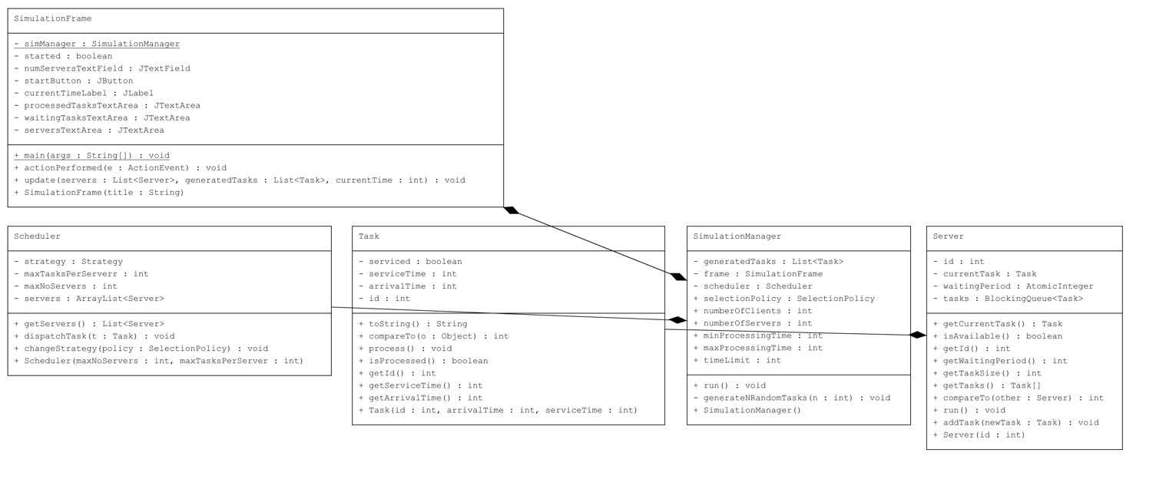

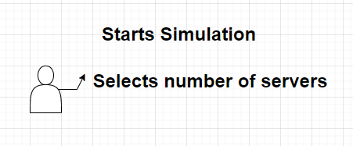

# Bibliography

Cay S. Horstmann, Java Concepts: Compatible with Java 5, 6 and 7, Publisher: Wiley, ISBN: 978-0470509470, Published: 2011.

Joshua Bloch, Effective Java (2nd Edition), Publisher: Addison-Wesley Professional, ISBN: 978-0321356680, Published: 2008.

Herbert Schildt, Java: A Beginner's Guide (6th Edition), Publisher: McGraw-Hill Education, ISBN: 978-0071809252, Published: 2014.

Robert Lafore, Data Structures and Algorithms in Java (2nd Edition), Publisher: Sams, ISBN: 978-0672324536, Published: 2002.

Sedgewick, Robert and Wayne, Kevin, Algorithms, Fourth Edition, Publisher: Addison-Wesley Professional, ISBN: 978-0321573513, Published: 2011.

Oracle's official Java documentation, which includes detailed explanations of the Java class libraries and APIs. https://docs.oracle.com